This question has four parts [a, b,c, and d], each of which counts for 2 points. Answer each question in the text box provided. All parts of the question relate to the following information:
Suppose Mary and Kate both can produce cookies and muffins. Suppose thy have the following production possibility frontiers:

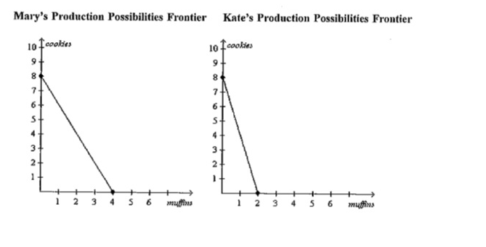
Question 1: What is Mary’s opportunity cost of one muffin? Explain in one sentence.
Question 2: What is Kate’s opportunity cost of one muffin? Explain in one sentence.
Question 3: Who has a comparative advantage in making cookies? Explain in one sentence.
Question 4: If Mary and Kate trade foods with each other, who will trade away muffins in exchange for cookies. Explain in one sentence.

